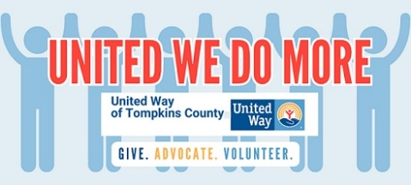
United Way of Tompkins County
313 North Aurora Street
Ithaca, New York 14850
Phone 607.272.6286
Fax 607.272.2736
www.uwtc.org

June 3, 2025

Tompkins County Legislature
121 E. Court Street
Ithaca, NY 14850

Dear Tompkins County Legislators:

My name is Michael Ramos and I serve as President & CEO of United Way of Tompkins County. For more than 100 years, United Way of Tompkins County has animated collective impact toward a community where all people thrive. Coming alongside the more than 100 human service and community-based agencies and organizations we assist through funding on an annual basis, we transform the dynamics of poverty in Tompkins County by addressing human need and creating conditions for economic security for all. We directly support 15 programs that address food insecurity as their mission. A recent site visit to the food pantry in Groton found that they are encountering double the number of people coming for assistance as previously. Staying stably housed and emerging from food insecurity are considerably more challenging given federal cuts.

Food production, access and distribution is the first, most vital, and most visible sign of a county that embraces an authentic social contract. The level of food insecurity in our community (12% in the U.S. as a whole) is a measure of our community’s health, alongside other basic needs which are also being challenged. As a two-year resident of Tompkins County, I have been heartened by how when it comes to food, the community itself is consistently organizing resources and organizing people, from community supported agriculture to cooperative markets to salvaging food to the food bank and pantries to reaching elders on a daily basis to community meals. What we do in this community together is truly remarkable. We come together committed to making the vision of a sufficient, sustainable future a reality by working collaboratively and collectively, breaking down silos and sharing power.

We are all impacted by federal cuts and likely cuts. We must face the challenge before us together and proactively. Consistent with what you have heard from other food partners tonight, there is no separation from farmers being hurt and farmworkers being harmed, there is no “us and them” when it comes to providing the resources necessary so that no one goes hungry in Tompkins County. How can we ensure that everyone who needs it can get SNAP? How can we ensure that everyone is reached who cannot leave their home for food? How can we communicate to the state that the rainy day is now and not to wait until the rug is pulled out from local food systems to lend additional funding for the Hunger Prevention and Nutrition Assistance Program and other supports? How can we work with the county legislature, this one and the one to form in the fall, to invest in food resiliency and equity, especially with additional cuts pending to communal health?

Today, we are painting a picture of the local reality, seeking further partnership as new developments that impact community members’ lives unfolds. United Way stands as part of the collaborative system for collective solutions that makes Tompkins County the resource-full community that we are. When it comes to food, we can come together as one, through existing networks and beyond. For UWTC, we aim high – for all our community to flourish. Government, the food distribution network, local businesses and markets, public and private philanthropy and people serving others food can imagine and enact measures that leaves no one behind. We look forward to conversation with you and our wonderful new County Administrator, Korsah Akumfi.

Thank you for your openness to hear us on this issue today.

Sincerely,

Michael Ramos
President & CEO

